**Other Errors and Broken Pages**

**Front End**

1. An Error appeared after testing an order and then clicking the profile name and the Kinman Logo

Clicking this two while on this page will cause an error

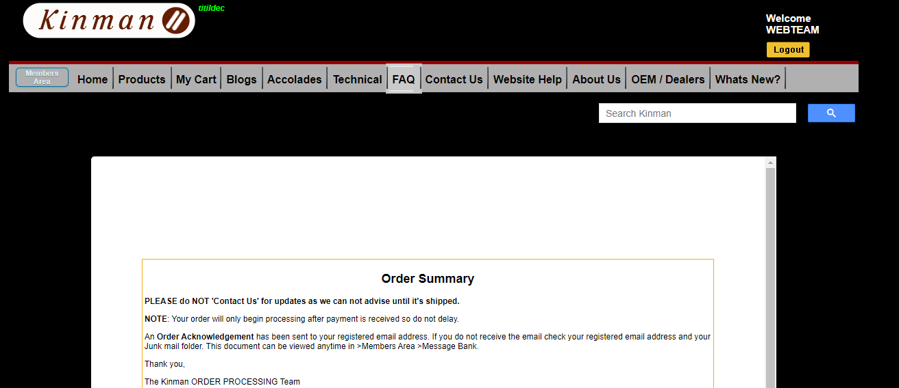

**Check other links too if the error appears as well**

Error :

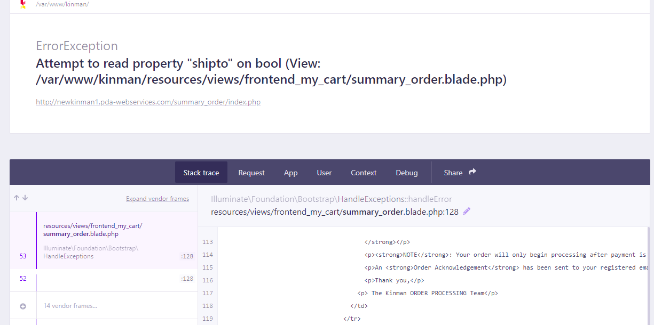

1. Page not found : <http://newkinman1.pda-webservices.com/messages.php>

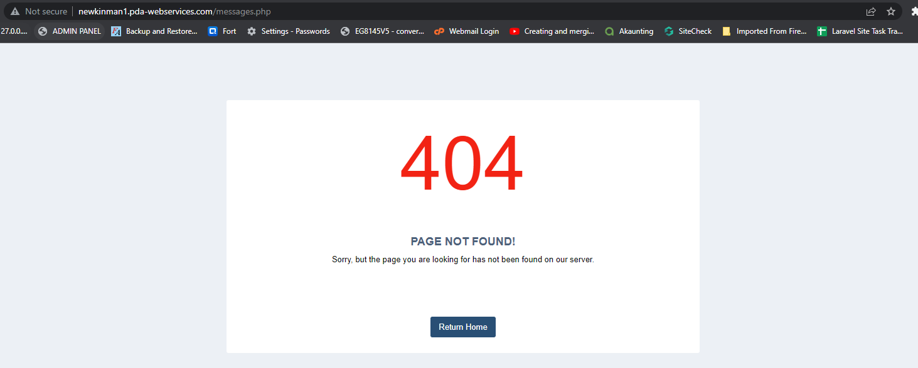

1. The results on the search bar are linked to the PHP site



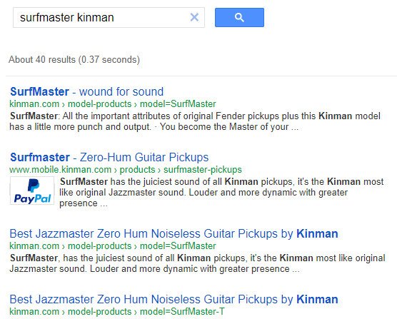

1. This button should change depending on what kind of customer is logged in

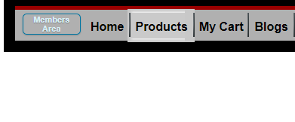

If the customer is a regular member : if the customer is a dealer:

 

1. Error in viewing message

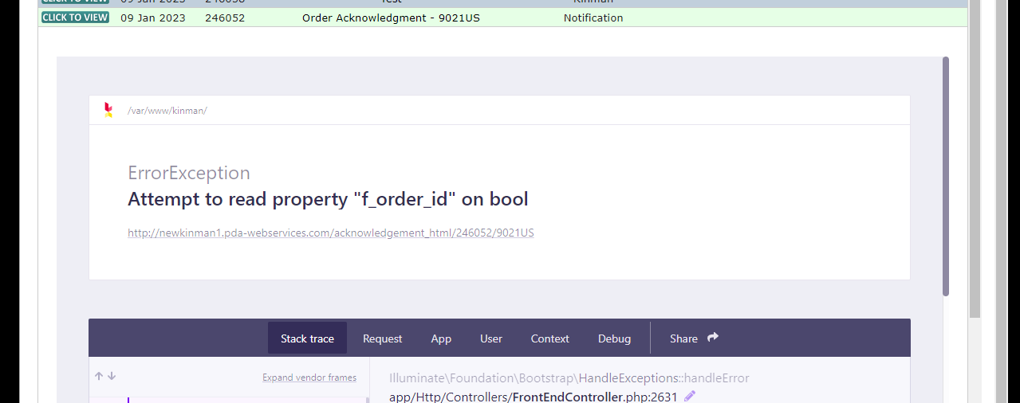

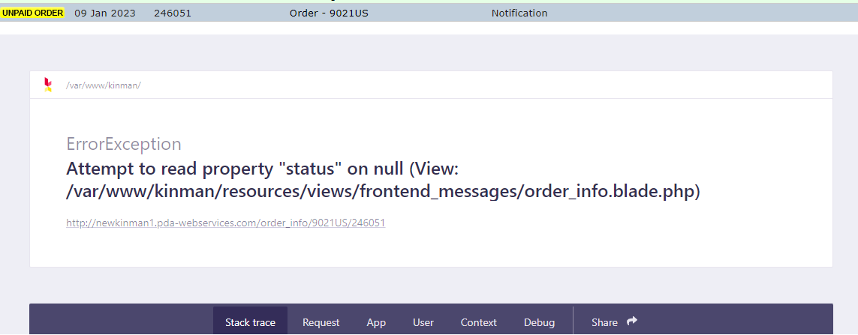

1. Like Button is missing, check all pages for this issues. Some that I found is from [Accolades](http://newkinman1.pda-webservices.com/acolodes) , [OEM / Dealers](http://newkinman1.pda-webservices.com/oem-dealers) and most of the pages under [Technical](http://newkinman1.pda-webservices.com/tech-support) tab

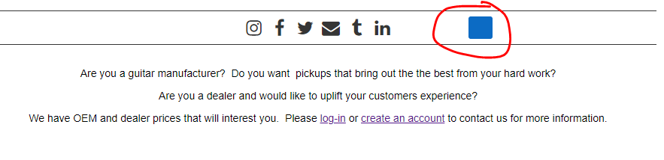

1. Clicking “Home” brings me here

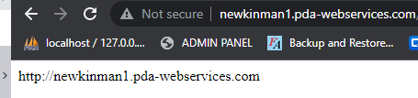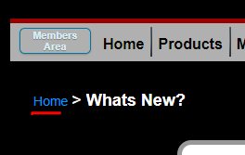

1. 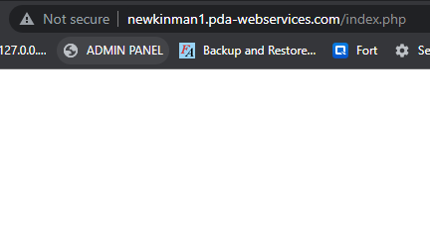Clicking the Logo goes to a blank page

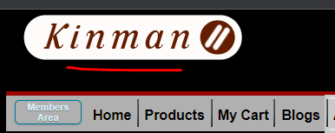

1. Some links on the [Accolades](http://newkinman1.pda-webservices.com/acolodes) page are dead/broken or not linked to the right page.

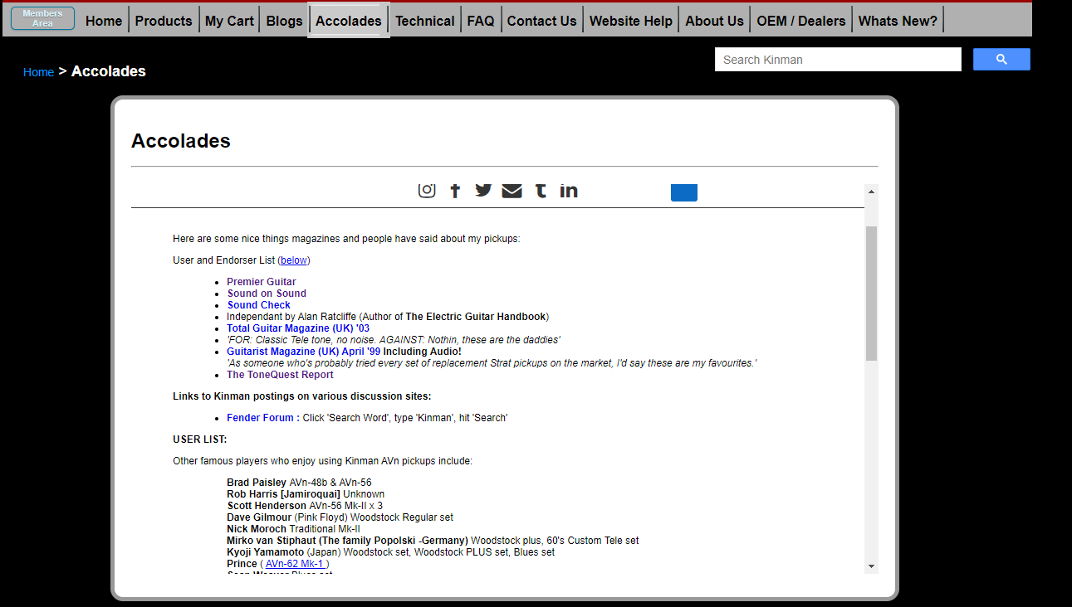

[Sound Check](http://newkinman1.pda-webservices.com/pdf/Soundcheck-Germany.pdf):

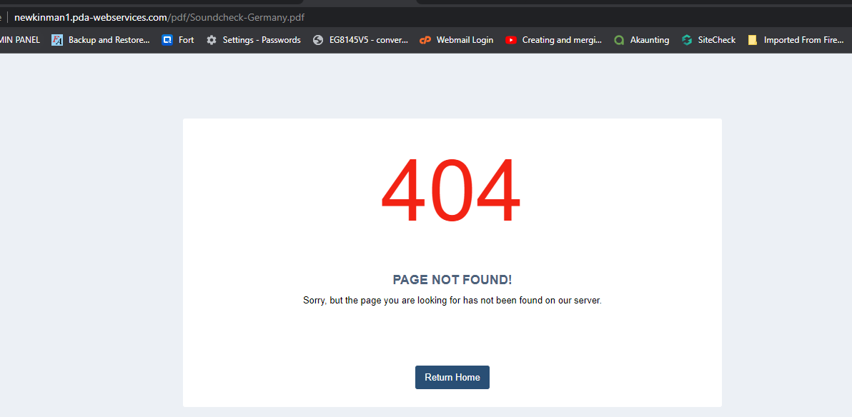

**Prince** ( [AVn-62 Mk-1](http://kinman.com/InstallGuide/AVn-62-Mk-1/AVn-62-Mk-1.php" \t "http://newkinman1.pda-webservices.com/_blank)) - this page is still linked to the PHP site

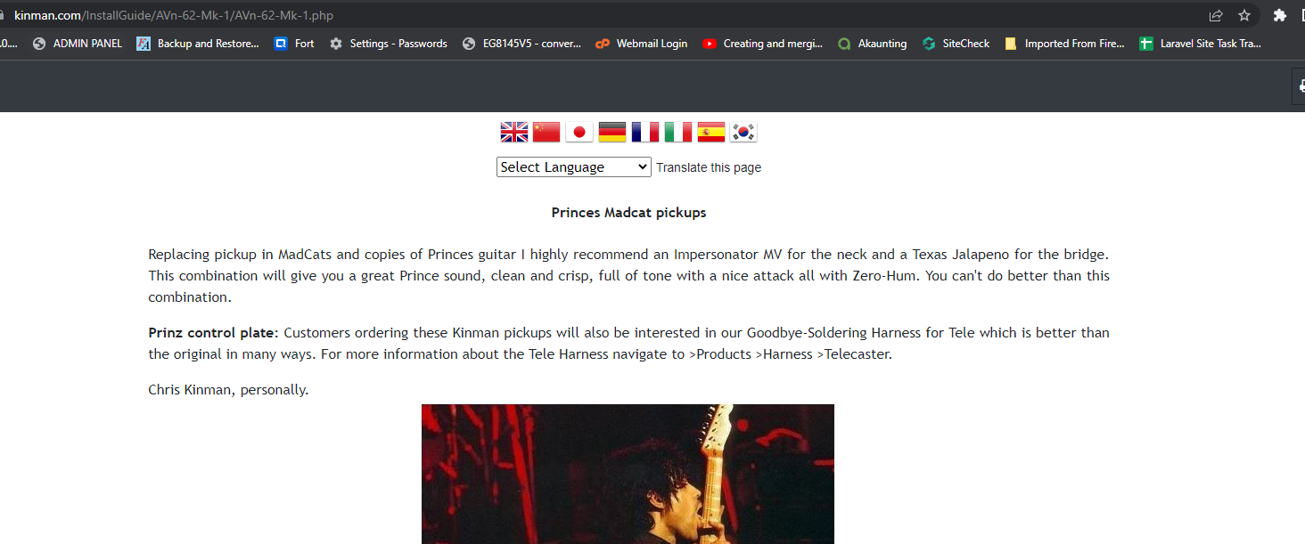

1. In the Install Guides page, if the user is already logged in. The install guides should be visible already.

As you can on the image below, I’m already logged in

But the login for install guides is still there

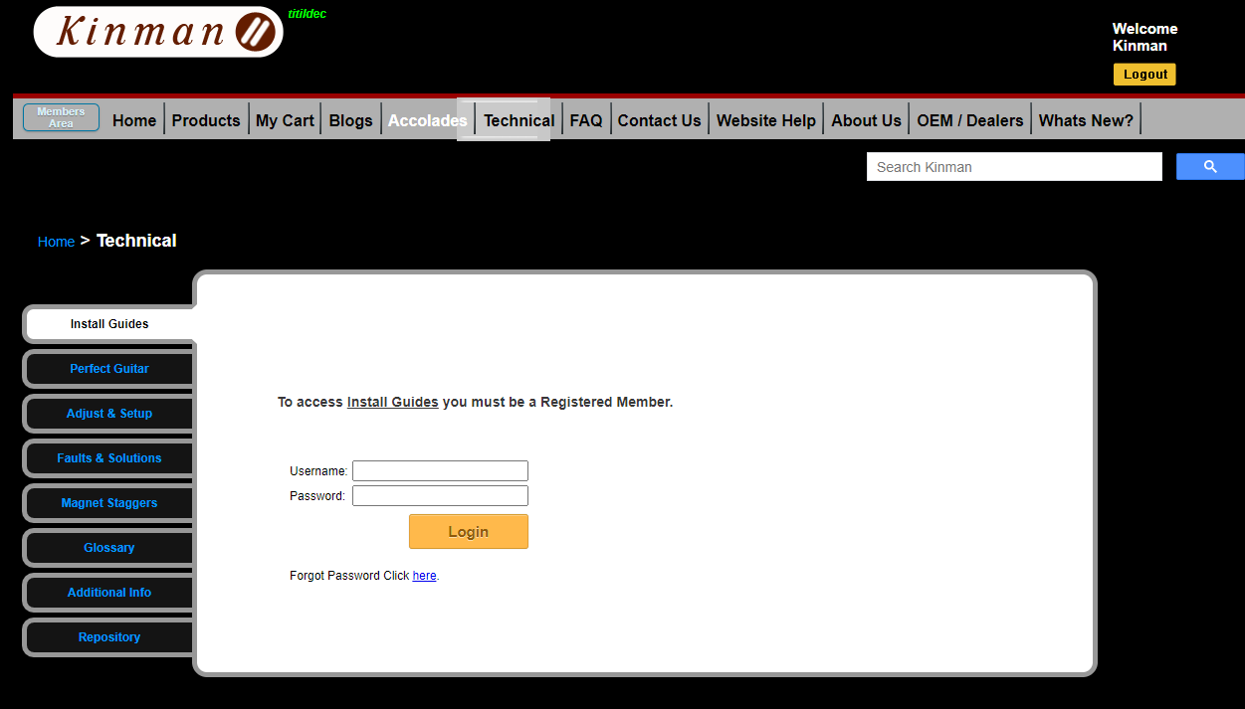

This is how it should appear when a use is already logged in

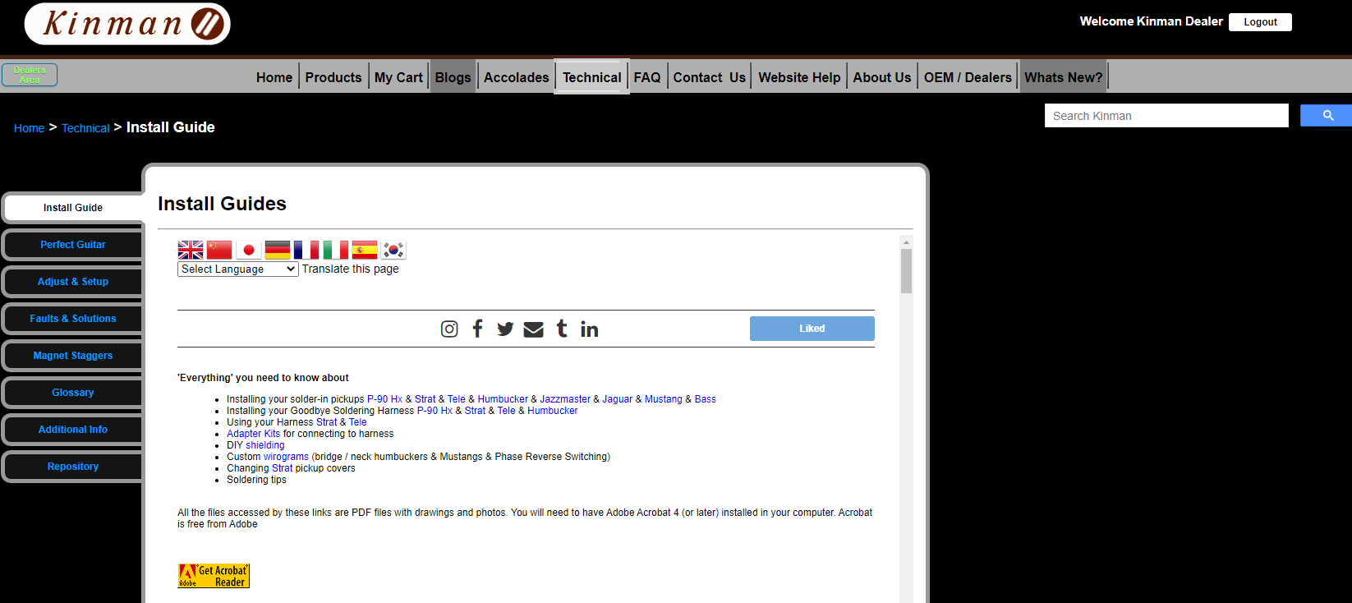

1. Under FAQ tab, there are a lot of links that are broken or are not connected to the laravel site.

**Admin**

1. On the Users > Admins > Edit page, There should be a Password field

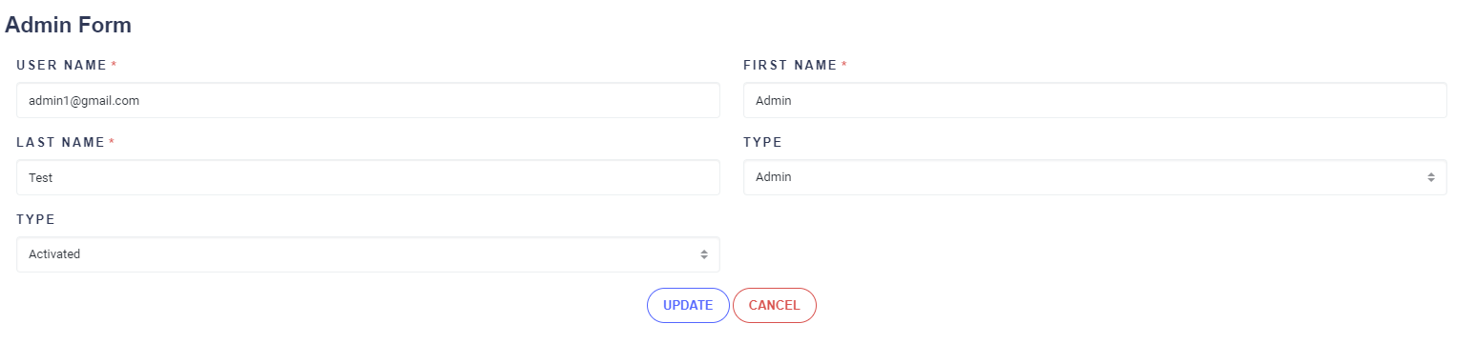

Like this :

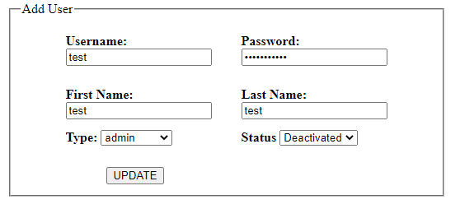

1. User Level, there are two level of access on the admin.

Admin level has all the controls, Production level has limited access

This are the only menus the Prodcution User can see. (**User** and **Delayed Queue** tab are not available for Production level User)

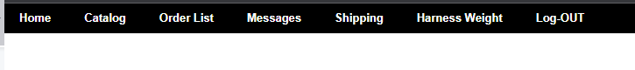

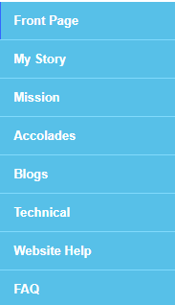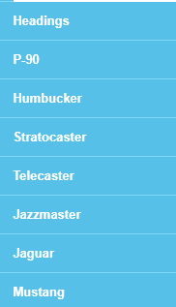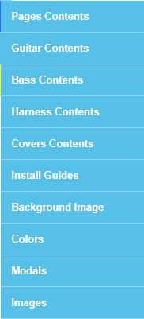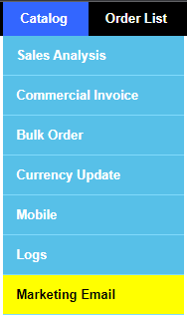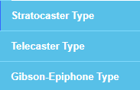And on the Catalog tab, some links are not available for Production level user, this are the only links available for them

Links under “Harness Contents”

Links under “Pages Contents”

Links under “Guitar Contents”

**You can check the codes for this inside Admin folder and open the file “_INC_header.php”**

1. Login Window, remove the “Forget Password”, and the “Remember Me” is not working.

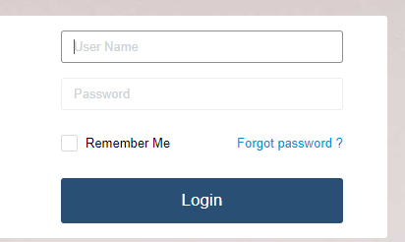

1. Login Session is not working properly

- when you close the window, the login session disappears right away, there should be a time before the session is destroyed when the window is closed without logging out.

- after logging out, clicking the back button should prevent the user from getting logged in again, when you click back after logging out, the user should be redirected to login page.